

Supplier Enablement
Case Study



The New York Times
Solution Overview
Microsoft Gold Certified Partner
Sapient Corporation
Industry
Media
Challenge
The New York Times newspaper needed a more efficient way to exchange information between its mainframe and its partners’ wide variety of computing platforms.
Solution
Sapient Corporation used Microsoft® BizTalk™ Server to automate file exchange, integrate the newspaper’s key systems and facilitate data exchange over the Internet. Now, file transfer and billing are fully automated and partners can choose when and how to send and receive data.
Microsoft Software and Services
- BizTalk Server 2000
- Windows® 2000 Advanced Server
- SQL Server™ 2000 with Analysis Services
- Visual Basic®
- Visual SourceSafe®
- Microsoft Consulting Services
Other Software
Xcellenet
Benefits
- Reduce error rates
- Save on production and distribution costs
- Allow for anytime information exchange with partners
- Simplify business for partners
- Reduce help desk burden caused by file transfer problems
- Increase accountability
- Improve customer service by reducing error rates due to file exchange issues
- Solution implemented in 3 months


B2B Partner Enablement: BizTalk Server Makes it Simple
Published: August, 2002.
To provide home newspaper delivery, The New York Times newspaper and its national delivery partners exchange files on a daily basis. That exchange presented a challenge: accommodating partners’ file formats required constant adjustments to the mainframe and data fields were often unable to be analyzed properly, leading to unacceptable error rates and customer complaints.
Sapient, a Microsoft Gold Certified Partner, used Microsoft® BizTalk Server to create a platform that would allow for seamless, automated B2B data exchange in just three months. Now, with a few dozen partners online, error rates are being reduced, customer service is improving, and the newspaper stands to improve revenues and reduce production and distribution costs each year.
Challenge
Streamlining the partner-to-partner information exchange
For the approximately one million subscribers who get The New York Times delivered to their home in the morning, the process seems simple: they order the subscription and the paper appears. The logistics of making that delivery happen, however, are far more complex. The New York Times newspaper contracts with over a hundred national partners in local markets to make many of its home deliveries. Keeping the system running smoothly requires a constant exchange of information between the newspaper and its partners on everything from billing to complaints to changes in delivery status such as vacation stops and restarts.
Until recently, that exchange was laborious and error-prone. The problem was the usual one: the difficulty of transferring information between the newspaper’s mainframe and the many different systems used by its delivery partners. To communicate with its partners, The New York Times was using a network of dedicated PCs set up at its partner businesses. Full file reconciliations were infrequent and error rates were high, since the data fields could not be analyzed easily. Correcting the mistakes was difficult: once a month, partners would receive a huge file listing the discrepancies, which they would have to print out and manually search.
“In terms of price performance ratio and the ability for people to pick it up and learn it very quickly, BizTalk Server was the best choice.”
Dan Hennessey
Director of Circulation
Fulfillment Systems
The New York Times

The system had other costs as well: adding new partners required programming adjustments in the mainframe, slowing business growth, and the information exchange process was error-prone.
Solution
Integration, automation, enablement in just three months
The Times needed a solution that would: a) provide for smooth, reliable information exchange with its delivery partners; b) help integrate key enterprise applications; and, c) allow for the automation of key business processes. The solution had to offer partners the convenience of receiving files via e-mail, ftp or through a Web site download, and simplify the process of adding new partners. It had to be capable of processing a large number of small files and a small amount of large (>2MB) files, and be able to support XML, which Times decision-makers expect will eventually replace the flat, positional files currently used for data exchange.
Sapient: strategic vision, proven track record
Sapient Corporation, a Microsoft Gold Certified Partner, had already delivered several high-quality solutions for The New York Times, but this didn’t translate into an automatic “in” for the delivery partner project. RFPs were put out and the resulting six proposals were subjected to a rigorous screening process in which they were ranked numerically on such key issues as strategic vision, marketing experience, and focus on user experience as well as project methodology and development capability. On a purely objective basis, Sapient still came out ahead, according to The Times’ director of circulation, fulfillment systems. “Sapient put together a very strong case, which demonstrated that they did a lot of work to understand the business problem even before the project began,” he says.
The right technology: BizTalk Server brings it all together
Sapient helped the newspaper review five different products before selecting Microsoft BizTalk Server as the platform for the solution. With its ability to map between different file formats, BizTalk Server would create the seamless and efficient data exchange The New York Times needed, according to Kris Kniaz, Software Architect with Sapient. BizTalk Server also could integrate the newspaper’s many heterogeneous environments, including its mainframe system and its new B2B Web site. Key business processes would be automated, and the newspaper would gain a comprehensive view of its home delivery process.
BizTalk Server also offered another benefit: fast time-to-market. With the tools provided in BizTalk Server and SQL Server™ 2000, Sapient developers were able to leap over some of the usual programming requirements, speeding the project and lowering costs.
The ability to define business processes and make them work with existing tools is just amazing with BizTalk Server and SQL Server 2000.”
Kris Kniaz
Software Architect
Sapient Corporation

“The ability to define business processes and make them work with existing tools is just amazing with BizTalk Server and SQL Server 2000,” says Kniaz. “For example, The Times wanted to give customers the ability to exchange not only flat files but also Microsoft Excel and Access file formats – and that usually requires lots of lower-level programming. But SQL Server 2000 has the ability and graphical user interface to let you define and extract data from Excel and Access easily, so by using SQL Server with BizTalk Server, we were able to handle those files with minimal programming effort.” To do this, Kniaz and his team invoked SQL Server Data Transformation Services (DTS) objects from the BizTalk orchestration via a script. “Overall, the tools were very easy to use and that allowed us to provide value to our clients in a very short time,” Kniaz says.
According to Hennessey, there was another reason to go with BizTalk Server: the XML capabilities of the Microsoft platform with .NET technology. “In terms of XML, Microsoft is on track,” he says.
With the new solution, which was completed in three months, the process of formatting, mapping and delivering files between The New York Times and its partners is completely automated. Partners no longer have to submit information at a set time or wait around for downloads: they can exchange information with the newspaper when they choose and in the format that is most convenient for them. A goal is to increase the amount of delivery information that is synchronized automatically, rather than manually, eliminating most errors. Signing up new partners is easy: using BizTalk Server tools, the newspaper can quickly describe the format or choose one of the existing formats, allowing it to add a new partner in a day, versus the week that it took previously.
Partners maintain preference information about their delivery times, file formats, and delivery mechanisms on The New York Times Web site. Every morning a program controlled by the Windows® Scheduler reads the client preference data from the Oracle database and determines whether a file should be sent to or received by a particular partner that day. This information (a “job”), is then stored in the SQL Server database in a custom-created job queue table. Because every file type is handled by a different business process (implemented as a schedule), the job entries in the SQL Server database also contain the type of business process or “orchestration schedule” needed to handle that file type. Every few minutes, another executable, called the dispatcher, reads entries from the job queue table, selects them as XML and submits them to the appropriate BizTalk Messaging Channel, which is connected to the orchestration schedule that handles that particular file type. Incoming files are then delivered to the mainframe via the legacy Xcellnet software; outgoing files are delivered in the correct file format to the ftp site or email address chosen by the partner.
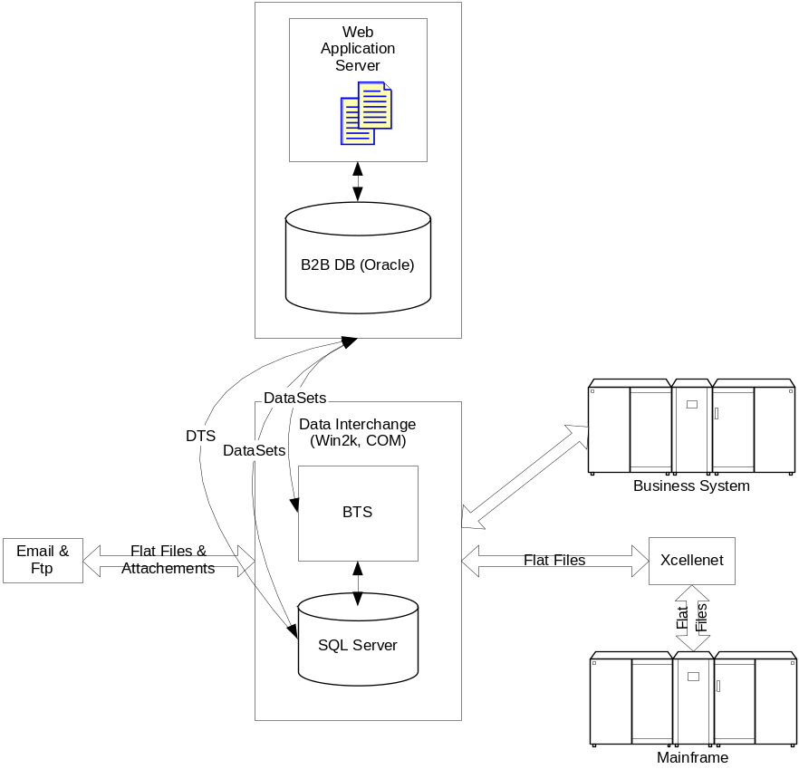
“Thanks to their wealth of expertise and close contacts with the BizTalk project team, MCS consultants provided important help during both the technical design and the implementation.”
Kris Kniaz
Software Architect
Sapient Corporation

The solution can support small files as well as very large feeds (>10MB). Developers also incorporated SQL Server DTS to meet The Times’s goal of supporting partners who use Excel and Access files. Currently, the system is moving flat positional files and reports but soon it will be used to dispatch EDI-based invoices after mapping them from XML sources provided by a second back-end system. The solution also integrates the company’s other mainframe, which contains billing information, allowing for automation of the billing process.
The solution is currently serving a few dozen business partners, with an additional 100-plus expected to sign on soon, and will eventually handle more than 500 transactions a day. Future growth should be easy to accommodate: if processing time starts to grow, The New York Times can add more BizTalk servers. Currently, the solution uses two Compaq Dual Processor M580 servers, one for BizTalk Server, the other for SQL Server.
Sapient worked closely with Microsoft Consulting Services during the development. “Thanks to their wealth of expertise and close contacts with the BizTalk project team, MCS consultants provided important help during both the technical design and the implementation,” Kniaz says. “The result was a solution that performed better.”

Benefits
Making it easier to do business
For More Information
About Sapient Corporation
One Memorial Drive
Cambridge, MA 02142
Tel: 617.621.0200
Fax: 617.621.1300

E-mail: info@sapient.com
Web site: http://www.sapient.com
Sapient, a leading business and technology consultancy, helps Global 2000 clients achieve explicit business outcomes through the rapid application and support of advanced information technology on a fixed-price basis. Founded in 1991, Sapient employs more than 2,300 people in offices in Atlanta, Austin, Cambridge (Mass.), Chicago, Dallas, Denver, Düsseldorf, Houston, London, Los Angeles, Milan, Munich, New Delhi, New York, San Francisco, Tokyo, Toronto and Washington, D.C.

About Microsoft
.NET Enterprise Servers are a comprehensive family of Microsoft server applications for quickly building, deploying and managing integrated, Web-based solutions. Designed to deliver mission-critical performance, .NET Enterprise Servers are built from the ground up for interoperability using public Internet standards such as XML.
For more information about Microsoft products or services, call the Microsoft Sales Information Center at (800) 426-9400. In Canada, call the Microsoft Canada information Centre at (877) 568-2495 or (905) 568-0434. Outside the 50 United States and Canada, please contact your local Microsoft subsidiary.
For more information about Microsoft solutions, visit the Microsoft Business
page at www.microsoft.com/business.

© 2002 Microsoft Corporation. All rights reserved.
This case study is for informational purposes only. MICROSOFT MAKES NO WARRANTIES, EXPRESS OR IMPLIED, IN THIS SUMMARY. The information contained in this document represents the current view of Microsoft Corporation on the issues discussed as of the date of publication.
Microsoft,, BizTalk, SQL Server, and Windows are either registered trademarks or trademarks of Microsoft Corporation in the United States and/or other countries/regions. The names of actual companies and products mentioned herein may be the trademarks of their respective owners.
Microsoft Corporation • One Microsoft Way
Redmond, WA 98052-6399 • USA

Now, doing business with The New York Times is much easier for its delivery partners. The company is benefiting, too: With files available on the Web site, The New York Times has been able to reduce the burden on the help desk function and significantly cut back on support services. The error rate has already dropped for participating partners; overall, the newspaper expects to dramatically reduce previous discrepancy rates within the first year of the system’s operation. And, with the ability to add new partners quickly, The Times can expand delivery capabilities, and thus grow its subscriber base, much more rapidly.
The Times’ B2B portal solution also provides other, less tangible benefits, such as increased accountability. “Accountability is a benefit that’s hard to quantify but it’s critical,” Hennessey says. “Now everyone from the publisher to the staff can see what’s going on. If there are multiple complaints, for example, we can drill down and look at why that is.”
But the biggest benefit, according to Hennessey, is improved customer service. With faster, more reliable information sharing, The New York Times and its partners are reducing delivery errors and responding more quickly to customer needs. Not only are the newspaper and its partners getting more papers delivered on time, but they’re doing it with fewer headaches and at a lower cost.
“Our objective was really to simplify business interactions for our partners as well as for ourselves, and we’ve done that,” Hennessey says.

